**LAPORAN PRAKTIKUM PENGOLAHAN CITRA DIGITAL**

**8. OTHER HISTOGRAM MODIFICATION TECHNIQUES**



**Disusun oleh :**

**Nama : Garcia Bryan Farrel**

**NPM : 2327250026**

**Kelas : IF41**

**PROGRAM STUDI INFORMATIKA**

**FAKULTAS ILMU KOMPUTER DAN REKAYASA**

**UNIVERSITAS MULTI DATA PALEMBANG**

**2024**

**TUTORIAL : OTHER HISTOGRAM MODIFICATION TECHNIQUES**

**Goal**

The goal of this tutorial is to learn how to perform other common histogram modification operations.

**Objectives**

* Learn how to adjust brightness of an image by histogram sliding.
* Learn how to use the imadjust function.
* Learn how to use the stretchlim function.
* Explore adjusting image contrast through histogram stretching (also known as input cropping).
* Learn how to adjust image contrast with histogram shrinking (also known as output cropping).

**Procedure**

Histogram sliding is the process of adding or subtracting a constant brightness value to all pixels in the image. When implementing histogram sliding, we must make sure that pixel values do not go outside the boundaries of the gray scale. Therefore, any pixels that result in values greater than 1 after adjustment will be set to 1. Likewise, any pixels resulting in values less than zero after adjustment will be set to 0.

1. Display original image and prepare subplot.

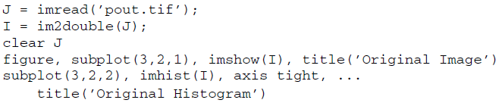

1. Obtain a brighter version of the input image by adding 0.1 to each pixel.

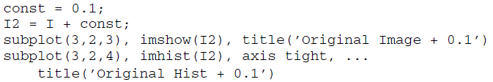

|  |
| --- |
|  |
|  |

**Question 1** How did the histogram change after the adjustment?

|  |
| --- |
| Karena menambahkan konstata 0.1 mangkanya bisa dilihat dari histogramnya bergeser ke kanan. |

1. Produce another brighter image by adding 0.5 to original image.

|  |
| --- |
|  |
|  |



**FIGURE 8.1 Gamma transformations for different values of gamma**

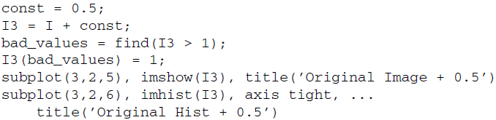

|  |  |
| --- | --- |
|  |  |

**Question 2** What does the variable bad_values contain?

|  |
| --- |
| Variabel bad_values berisi indeks I3 yang memiliki nilai intensitas lebih dari 1 setelah penambahan 0.5. Sehingga nilainya dianggap saturasi dan akan diubah menjadi 1 pada baris I3(bad_values) = 1. |

**Question 3** Why does the third plot show such an excessive number of pixels with a value of 1?

|  |
| --- |
| Dikarenakan I3(bad_values) = 1 yang menyebabkan peningkatan jumlah piksel pada nilai intensitas maksimum. |

The brightness of an image can also be modified using the imadd function, which takes care of truncating and rounding off values outside the desired range in the output image. Histogram stretching and shrinking can be achieved through use of the imadjust function. The syntax for the function is as follows:



|  |
| --- |
|  |
|  |

Figure 8.1 illustrates what the transformation functions look like when different values of gamma are used. As we already know from Chapter 9, the value of gamma is the exponent in power law transformation. Any values below low_in and above high_in are clipped or simply mapped to low_out and high_out, respectively. Only values in between these limits are affected by the curve. Gamma values less than 1 create a weighted curve toward the brighter range, and gamma values greater than 1 weight toward the darker region. The default value of gamma is 1. Let us explore how to use imadjust to perform histogram stretching.

1. Close any open figures.
2. Execute the following code to see histogram stretching on the pout image, which is already loaded in variable I.

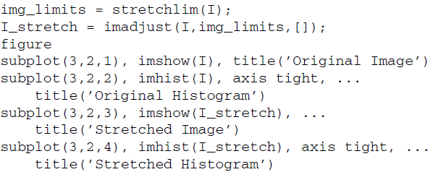

|  |  |
| --- | --- |
|  |  |

**Question 4** How did the histogram change after the adjustment?

|  |
| --- |
| Disebankan karena imadjust dengan batas yang ditentukan oleh stretchlim histogram akan tersebar lebih merata ke seluruh rentang intensitas 0-1. Menyebabkan peningkatan kontras terutama di area dengan intensitas rendah atau tinggi yang sebelumnya berdekatan. |

**Question 5** What is the purpose of using the stretchlim function?

|  |
| --- |
| Fungsi stretchlim digunakan untuk menentukan batas intensitas bawah dan atas agar rentang intensitas citra dapat diperluas untuk meningkatkan kontras. |

In the previous step, we specified the low_in, high_in, low_out, and high_out parameters when calling the imadjust function when in fact the default operation is histogram stretching—meaning these parameters are not necessary to perform histogram stretching. Notice in the next step how just calling the function and only specifying the image as its parameter will give the same results.

1. Perform histogram stretching with imadjust using default parameters and confirm that the results are identical to the ones obtained before.

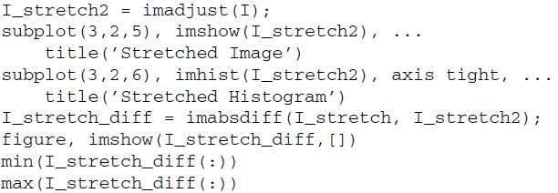

|  |
| --- |
|  |
|  |

**Question 6** How does the difference image look?

|  |
| --- |
| Tampilannya saat dijalankan hanya muncul warna hitam karena pixel nya 0. |

**Question 7** What is the purpose of inspecting its maximum and minimum values?

|  |
| --- |
| Berfungsi agar mengetahui jumlah max dan min image seberapa stretch nya. |

To shrink an image histogram, we must specify the parameters explicitly.

1. Close any open figures and clear all workspace variables.
2. Execute the following code to see the result of histogram shrinking.



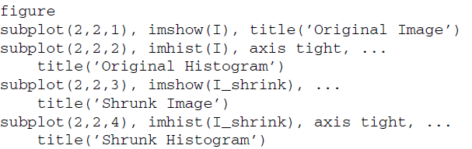

|  |
| --- |
|  |
|  |

When we use other techniques to adjust the histogram of an image, we have a means to view the transformation function (i.e., the histeq function will return the transformation function as an output parameter if requested). There is no built-in technique for viewing a transformation function when performing histogram sliding, stretching, or shrinking, but we can achieve a visual representation of the transformation function by using the plot function. To do so, we specify the original image as the X values and the adjusted image as the Y values.

1. Display the transformation function for the adjustment performed in the previous step.

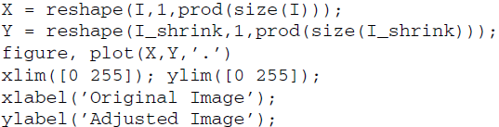

|  |
| --- |
|  |
|  |

**Question 8** What do the above first two statements in the code do?

|  |
| --- |
| I dan I_shrink menjadi vektor baris satu dimensi semua piksel citra tersebut dijajarkan dalam satu baris dengan panjang sebanyak jumlah pikselnya. |

**Question 9** What does the xlabel and ylabel functions do?

|  |
| --- |
| Fungsi xlabel dan ylabel digunakan untuk memberi label pada sumbu x dan sumbu y pada grafik. Dalam kode tersebut xlabel('Original Image') memberi label "Original Image" pada sumbu x, dan ylabel('Adjusted Image') memberi label "Adjusted Image" pada sumbu y. |

As noted earlier, gamma values other than 1 will specify the shape of the curve, toward either the bright or the dark region.

1. Close any open figures.
2. Perform histogram shrinking with a gamma value of 2.

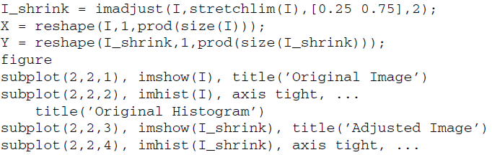



|  |
| --- |
|  |
|  |
|  |

**Question 10** The transformation function plot displays a gap from 0 to 12 (on the X axis) where there are no points. Why is this so?

|  |
| --- |
| 0 hingga 12 pada sumbu X terjadi karena pada citra asli (I), tidak ada piksel dengan intensitas antara 0 hingga 12. Berarti rentang intensitas tersebut tidak terdapat pada citra awal sehingga tidak ada titik dalam rentang tersebut pada plot transformasi. |